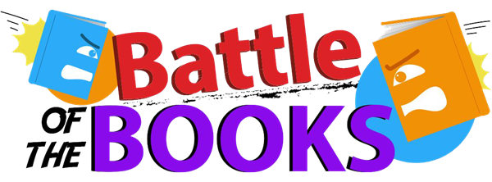
2022-2023 Field Battle of the Books Master List

Title | Author | Field Library | Axis360 | Subjects
All Thirteen: Incredible Cave Rescue Thai Boys' Soccer Team | Christina Soontornvat | Book / Call #: 796.52 SOONTORNVAT | eBook | - Non-Fiction  - Cave Exploration  - Life-Threatening  - Thailand  - Thailanders
The 1619 Project: Born on the Water | Nikole Hannah-Jones | Book / Call #: PICTURE BOOK HANNAH | eBook | - Picture Book  - Enslaved People  - African Americans Family History
City of Ember, The | Jeanne DePrau | Book / Call #: GRAPHIC DUPRAU | Not available | - Graphic Novel  - Fantasy  - Good vs Evil  - Dystopia
Crossover, The | Kwame Alexander | Book /Call # VERSE ALEXANDER | eBook & audiobook | - Family  - Brothers  - Basketball  - Illness
Maizy Chen’s Last Chance | Lisa Yee | Book / Call # REALISTIC YEE | eBook | - Realistic  - Family History  - Chinese Americans
Merci Suarez Changes Gears | Meg Medina | Book / Call # REALISTIC MEDINA | eBook | - Realistic  - Middle School  - Jealousy  - Family Stories
No More Dead Dogs | Gordon Korman | Book / Call # HUMOR KORMAN | eBook | - Humor Football  - Drama Club  - School Stories
Old Willis Place, The | Mary Downing Hahn | Book / Call # HORROR HAHN | eBook | - Ghosts  - Haunted Houses  - Siblings  - Friendship
Powerless | Matthew Cody | Book / Call # FANTASY CODY | eBook & audiobook | - Superheroes  - Supernatural  - Mystery  - Bullies
Song for a Whale | Lynne Kelly | Book /Call # REALISTIC KELLY | eBook & Audio | - Hearing  - Music  - Whales

